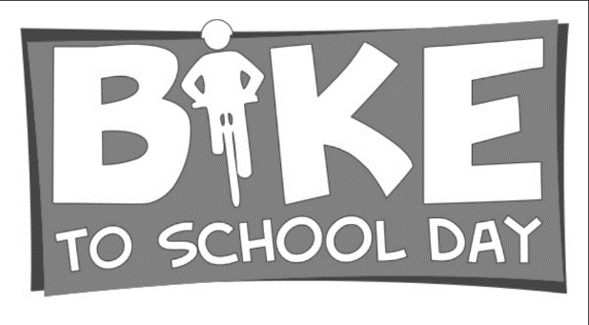
Monday 5th  Ride bike to school  3:30-4:15: Bike activities | Tuesday 6th  Red, White, and Blue:  Decorate bike American style/self and ride to school  3:30-4:15: Bike activities | Wednesday 7th  Ride bike to school  Early Release: no activities after school | Thursday 8th  Decorate your choice!  Decorate bike/self and ride to school  3:30-4:15: Bike activities | Friday 9th  Ride parade @ 8:30  Meet at South end of Western Skies(We will be escorted by Fire Engine and Police  No afternoon activities
Bikes and scooters are appropriate. No skateboards, roller skates, or electric bikes.
NOTE: Must return to teacher in order to participate in afternoon Bike Week Activities!!
Volunteers Welcome: Click link the link below
https://signup.com/go/dXAHium

Volunteers Welcome!
----------------------------------------------------------------------------------
I have discussed the rules with my child and we understand the risks involved with riding/walking home alone. In consideration for my child being allowed to participate with the afternoon “Bike Week” Activities, at Brown Elementary School, I hereby RELEASE AND AGREE TO INDEMNIFY AND HOLD HARMLESS Brown Elementary School, and their employees and agents, and the volunteers assisting the school, from any and all liability for injuries, damages, medical expenses, or any other loss to my child or family or me (including attorney’s fees) arising from or related to my child’s participation in this activity.

TO PARTICIPATE IN AFTER SCHOOL “BIKE WEEK” ACTIVITIES, YOU MUST SIGN THE PERMISSION SLIP AND RETURN TO YOUR TEACHER BY MONDAY, MAY 5th, 2025.
Child’s Name: ____________________________________ Teacher: ______________________Grade:____
Signature of Parent/Guardian_____________________________________ Date ____________
Phone number for emergency_____________________________

